**CalFresh Healthy Living, UC Brand Guide**

*CalFresh Healthy Living* is California’s SNAP-Ed program name. Each State and Local Implementing Agency uses this name in conjunction with their organization name. Please use this guide as CalFresh Healthy Living, UC and UCCE practitioners to appropriately apply logos and brand messaging. Also find elevator speeches, funding and non-discrimination statements, email signatures, and more.

# STATE

The University of California administers the SNAP-Ed grant through the State Office in Davis.

**Example:** The CalFresh Healthy Living UC logo is used by the State Office when providing technical assistance and trainings conducted by the State Office; reports written by the State Office in compliance with the USDA/CDSS grant such as the Final Report; materials and presentations for national conferences; studies led by the State Office.

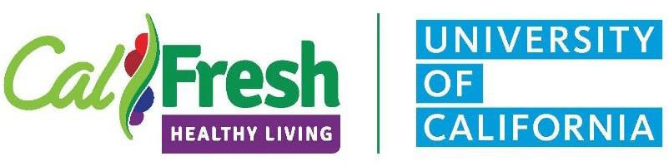

# [LOCAL](https://uccalfresh.ucdavis.edu/admin/program/brand/ucanrco-branding)

UCCE is the local implementing agency for CalFresh Healthy Living, UC.

**Example:** In compliance with the CalFresh Healthy Living brand guide, use the logo below for all communications and materials, such as events at schools and flyers related to local program implementation.

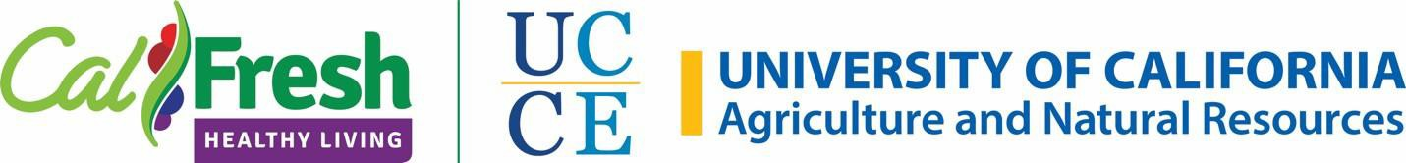

For integrated projects that involve other UC ANR programs, use the local implementing agency treatment and reference other organizations or statewide programs using copy.

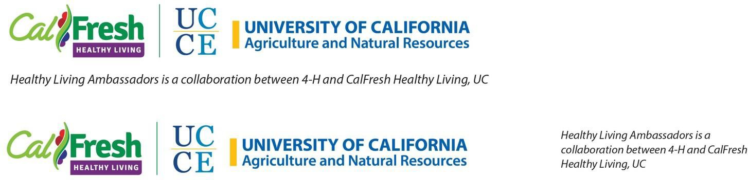

This guidance also applies to referencing the name of your County. Use the local implementing agency logo treatment and reference the County name using copy.

For County profiles or internal reports, refer to the program as “CalFresh Healthy Living, UCCE XX County” and use “the Program” for subsequent references.

# PARTNERSHIP STATE & LOCAL

When partnering with the CalFresh Healthy Living, UC State Office for events or other initiatives, use the partner logo treatment below.

**Example:** Use this logo treatment for State Office trainings led in conjunction with UCCE; materials and presentations for state conferences such as posters from counties for the CalFresh Healthy Living Forum; promotional materials that are used statewide.



## Messaging

For audiences with youth and adult participants in our program, please introduce yourself as follows:

*Example: “Hello, I’m XX from CalFresh Healthy Living, UC Cooperative Extension, XX county."*

For professional meetings with adults/partners, please include a reference to UC ANR:

*Example: " Hello, I'm XX from CalFresh Healthy Living, UC Cooperative Extension, XX county, part of a statewide network of programs called UC Agriculture and Natural Resources."*

In written materials, please include the standard UC ANR boilerplate to help audiences understand the impact of the division as a whole:

*UC Agriculture and Natural Resources brings the power of UC to all 58 California counties. Through research and Cooperative Extension in agriculture, natural resources, nutrition, economic and youth development, our mission is to improve the lives of all Californians. Learn more at ucanr.edu.*

**Elevator Speech**

#### Hi, I’m __________ with CalFresh Healthy Living, UC Cooperative Extension XX County. A USDA federally funded program.

*We work in low resource schools and communities offering free, effective, evidence-based nutrition and physical activity education, gardening, school wellness, and youth engagement strategies to improve health and wellness.*

*We partner with schools, community-based organizations, and non-profits to inspire long-lasting healthy change where people live, eat, work, learn, and play.*

*As a member of a statewide network of programs administered locally by UC Agriculture and Natural Resources and managed by UC Davis, we bring the educational expertise of the University of California to you.*

## Posters

**Place partnership logo treatment on a white background. Please do not place within a white box on CalFresh Healthy Living templates.** When discussing UCCE programs such as UC 4-H Youth Development, Expanded Food and Nutrition Education Program (EFNEP), the UC Master Gardener Program, or the UC Master Food Preserver Program it is recommended to **bold** the program names in the text of the poster and minimize the use of acronyms.

## Templates

For newsletters, PowerPoints, posters, flyers, etc., the [CalFresh Healthy Living Toolkit](http://calfresh.dss.ca.gov/cfhl/Partners) templates incorporate statewide branding guidelines. **Please reference the CFHL, UC website** [**Communication Resources**](https://uccalfresh.ucdavis.edu/commresources) **webpage for our program’s specific CFHL, UCCE and CFHL, UC + UCCE templates** which have funding and nondiscrimination statements.

[**CalFresh Healthy Living Branding Checklist**](https://calfresh.dss.ca.gov/Portals/41/Documents/CalFresh-Healthy-Living-Branding-Checklist-2023.pdf) **– an easy and quick way to ensure you are on the right track as you develop your CalFresh Healthy Living materials.**

## Funding and Nondiscrimination Statements

## [CalFresh Healthy Living USDA SNAP-Ed Funding and Nondiscrimination Statement Guidelines](https://calfresh.dss.ca.gov/Portals/41/Documents/CFHL-Funder-USDA-Statement-2023.PDF)

## This Guide includes multiple translations of the statements. Also available in the CalFresh Healthy Living Toolkit available on the [Partners page](https://calfresh.dss.ca.gov/healthyliving/partners) of the CalFreshHealthyLiving.org website

**Complete Statement:**

This material was funded by USDA’s Supplemental Nutrition Assistance Program - SNAP. This institution is an equal opportunity provider. Visit [www.CalFreshHealthyLiving.org](http://www.CalFreshHealthyLiving.org) for healthy tips.

**Space Limited Version:**

Funded by USDA SNAP, an equal opportunity provider. Visit [www.CalFreshHealthyLiving.org](http://www.CalFreshHealthyLiving.org) for healthy tips.

**Shortest Version:**

Funded by USDA SNAP, an equal opportunity provider.

## Duplicating or Editing SNAP-Ed materials

## Review Guidelines for Nutrition Education Materials for Guidelines for Duplicating or Editing SNAP-Ed Materials

## If materials are reproduced as is, nothing needs to be done.

## If any changes or additions are made to the content or design of SNAP-Ed materials, the SNAP and USDA logos must be removed and the following statement must be added:

## “Adapted from U.S. Department of Agriculture, Supplemental Nutrition Assistance Program. USDA does not endorse any products, services, or organizations. Provided by (organization’s name).”

## If the name or logo of an organization or company is added to the document, the SNAP and USDA logos must be removed and the following statement must be added:

## “Adapted from U.S. Department of Agriculture, Supplemental Nutrition Assistance Program. USDA does not endorse any products, services, or organizations. Provided by (organization’s name).”

## CALFRESH HEALTHY LIVING USDA SNAP FUNDING ACKNOWLEDGEMENTS

## Reference the latest information in the annual SNAP-Ed Plan Guidance. This includes how to use, duplicate, and edit SNAP-Ed materials and an updated link to the nondiscrimination statement in other languages. The full nondiscrimination statement (NDS) is rarely required for SNAP-Ed. However, it is necessary if SNAP or other FNS program eligibility or application information is provided. “New” is used in the Guidance to quickly identify areas updated for the current year. Example from the FFY 2024 SNAP-Ed Guidance illustrating updated information is below:

## NEW: All newly printed documents, pamphlets, websites, etc. that require the full NDS must use the FFY 2022 version. For online sites, individual webpages should have the full version of the NDS if there is information that requires the full statement to be featured even if it is on a different webpage of the site. A recommendation is to link to the appropriate version.

## The complete statement is required for longer and full-length materials, including but not limited to the following:

## • Books • Brochures • Conference Binders • Cookbooks • Corporate Identity Items (e.g., letterhead, folders, etc.) • Curricula • Murals (may be placed on separate plaque near mural) • Newsletters • Newspaper Articles (including editorials) • Periodical Articles • Registration Materials (e.g., forms, etc.)

## • Web sites/Web pages.

## *Instructional materials should include the acknowledgment on the back or inside cover, reference/citation pages, and any stand-alone components*.

## Translating Materials

If an agency updates, revises and/or translates FNS SNAP-Ed developed documents, they should include their agency’s name on the document and give credit to USDA. They should also **remove any USDA logos** and may add their agency’s name/program and logo(s) to the document. See an example below:

* + *“This material was adapted from U.S. Department of Agriculture (USDA), Supplemental Nutrition Assistance Program. USDA does not endorse any products, services, or organizations. Provided by (organization’s name).”*

*“The (organization name) is responsible for the (Dari) translation of this document.”* (Add this statement and the language if the document was translated)

*“This institution is an equal opportunity provider.”*

## Email Signatures

First and Last Name

Position Title

CalFresh Healthy Living, UCCE XX County Program Name(s)

Location (Physical address) Phone Number

Email (optional)

Local Implementing Agency Logo (see below)

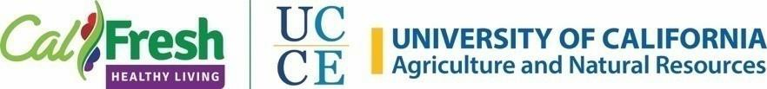

***For CFHL, UCCE + EFNEP joint appointment staff please use the following email signature:***

Name

Community Nutrition Specialist

CalFresh Healthy Living, UCCE XX County

UC Expanded Food and Nutrition Education Program

Location (Physical address) Phone Number

Email (optional)

***There is no joint logo for this appointment.***

**Identifying our Program on UC ANR Blog Webpage:** Please use the “CalFresh Healthy Living, UCCE” Tag on your blogs identifying our program.