

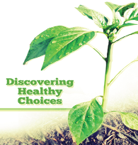
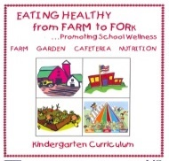
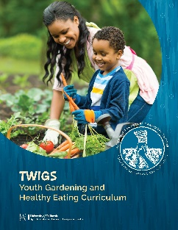
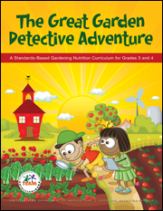
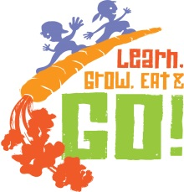
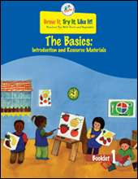

CalFresh Healthy Living, UC offers a wide range of garden curricula for all grade levels linking the classroom to the garden through various activities

Fleyr
CalFresh Healthy Living, UC Nutrition Education
UC Cooperative Extension, [Fill in Here] County

Preschool
Grow It, Try It, Like It

Grades K-2
Eating Healthy from Farm to Fork

Grades 2-3
Great Garden Detective Adventure
Jr. Master Gardeners: Learn, Grow, Eat, & Go!

Grades 4-6
Great Garden Detective Adventure
Jr. Master Gardeners: Learn, Grow, Eat, & Go!
Dig In!
Discovering Healthy Choices
Nutrition to Grow On

All Grade Levels
TWIGs

CalFresh Healthy Living, UC
Nutrition Education Program
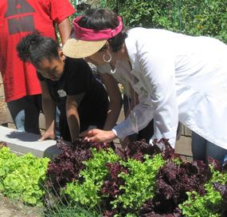
For more information contact:
Name: (Name) Office: (Phone Number) Email: (Email Address)

“The garden has promoted our school culture in many positive ways. Students are excited to work in the garden and see their plants grow. They love to water, weed and harvest. Their parents enjoy preparing the garden as a family activity. It has helped with school-parent communication and working together in a community partnership. Students are learning to make healthier choices and how food gets to our table. It has been a wonderful experience so far!”

--4th grade teacher, San Luis Obispo/Santa Barbara Counties
What We Offer
- Hands-on or virtual curriculum training
- Curricula that supports Common Core State and Next Generation Science Standards
- Nutrition education materials in “no prep” kits
- In-class presentations with food tastings or virtual lesson delivery
- Bilingual teaching materials (per request)
- Family newsletters and nutrition classes

Who We Are
The CalFresh Healthy Living, University of California Nutrition Education Program is a federally-funded program that offers nutrition education to limited-resource individuals, families and children. In California, CalFresh Healthy Living, UC is administered by the University of California Cooperative Extension (UCCE). CalFresh Healthy Living, UC assists limited-resource clients gain the knowledge skills, attitudes and changed behavior necessary to choose nutritionally sound diets and improve well-being.
What We Do
The youth program is delivered by UCCE staff and volunteer teachers in schools and community based organizations. Additionally, UCCE staff delivers adult and family-centered curricula. Staff and volunteers use one of several CalFresh Healthy Living, UC approved curricula. We provide our curricula and support at no cost when you partner with us!
Who Can Participate
Our services are offered at no cost to schools, organizations or programs where 50% or more of youth are eligible to receive free or reduced-price school meals.
Helping students make the grade with healthy foods!

