UCCE Educator Instructions
*Note: Depending on your version of Adobe, you may not have the ability to make edits or changes to these forms.
Please contact the State Office if you have any issues editing the form. We are happy to assist you.

For Counties with Adobe DC you may edit the following:
- SUBMIT FORM: Edit the “Submit Form” button on the PDF so the document will be emailed directly to the appropriate individual. Note: Please confirm with your supervisor and/or advisor who should receive the PDFs in order to know the appropriate email address to include.
  - Open PDF in Adobe Acrobat.
  - Select Tools in the top toolbar.
  - Select Prepare Form.
  - Right click on the “Submit Form” button.
  - Select Properties.
  - Select the Actions tab.
  - Click on “Submit a form” under the Actions box to highlight it.
  - Click the Edit button.
    - Edit the URL in the top bar to reflect the appropriate email address. You must begin with mailto: followed by your email address with no spaces. For example: mailto:xxxx@ucanr.edu or mailto:xxxx@ucdavis.edu
    - If you would like to include multiple email addresses for the PDF to be submitted to, simply separate subsequent email addresses with a semicolon (;). The mailto: introduction does not need to be included for subsequent email addresses after the first one listed. For example: mailto:xxxx@ucanr.edu; aaaa@ucanr.edu; bbbb@ucanr.edu
  - Click the OK button.
  - Click the Close button.
- Save the document per your county/cluster naming conventions. The saved document should have the revised “Submit Form” button so the extender can send the PDF directly to the appropriate person.

Directions for UCCE Educator to share with extender:
- Included in this email is a fillable PDF document (or print form) to record time spent teaching CalFresh Healthy Living – UC curricula. There is one PDF document per lesson of the curriculum.
- Open PDF on computer, tablet, or mobile device.
  - Note: PDF can be completed on smartphone or tablet with the FREE Adobe Reader App.
- Complete all grey, fillable sections.
  - Note: “UC Staff Use” section will auto-calculate, so you will not need to fill in this section.
- Include site name, extender/teacher name, and date.
  - Note: Educators may complete header components in advance (FFY and County Name).
- If an activity for that lesson was completed, check the box.
- Indicate the number of times that activity was taught.
  - Note: Do not include prep time or other support activities that are not part of the curriculum.
- Continue checking the boxes for each activity completed and indicate the number of times each activity was delivered.
- Did the extender spend additional time addressing curriculum objectives and/or doing physical activity breaks during the time this lesson was delivered? (e.g., discussing food groups on the lunch menu; go, glow, and grow foods; nutrients; brain breaks; energizers; etc) If so, select “yes” and then indicate the total additional time conducting activities supplemental to the curriculum.
  - Select the “yes” or “no” box to reflect any additional time for that lesson.
  - Record the total additional time in minutes spent addressing curriculum objectives and/or physical activity breaks outside of lesson delivery during the reporting period.
  - Note: If the extender is delivering CATCH® Lessons, they will need to complete the CATCH® Reporting Form and a separate Program Activity for their CATCH® Lessons will need to be created in PEARS. For more information please see the CATCH® Reporting Form Instructions.
- Did the extender use and/or distribute lesson support materials?
  - Select “yes” or “no” for each lesson support material.
- Add any comments. This is optional.
- Once the PDF is completed, click the “SUBMIT” button in the lower right hand corner.
  - It should prompt you to proceed with sending the form as an email to the UCCE Educator.
  - The form does not need to be saved prior to submitting/emailing to the UCCE Educator.

For Entering Data into PEARS:
- Prior to data entry into PEARS, the educator must review the ECE PARF for accuracy and completeness, and follow-up with the extender if there are any outstanding questions.
  - A second review for quality assurance by the supervisor of the ECE PARF and/or data entry into PEARS will reduce errors.
- Each ECE PARF collects data on one lesson. Report each lesson as one session in PEARS.
- The auto-calculated “Total Time” is the time entered for one session.
  - Note: If distributing as a hard copy form, the educator will need to calculate the total minutes.
- For example: In October, Ms. Jones delivered Activity 1 Book Reading once (auto-calculates 15 minutes) and Physical Activity MyPlate Toss once (auto-calculates 15 minutes) of Happy Healthy Me Lesson 1. She addressed curriculum objectives for a total of 20 additional minutes in October when she taught Lesson 1 through brief discussion at snack and lunch time. The Total Time should auto-calculate to 50 minutes. Enter one session at 50 minutes in PEARS for Ms. Jones.
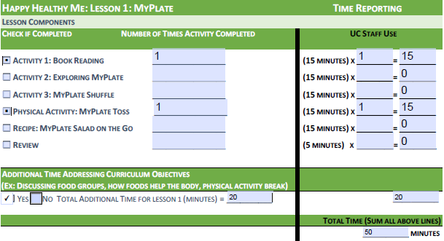
- Completed Youth PARFs should be kept on-file at the county-level for a minimum of 3 years from fiscal closure, plus the current fiscal year. These documents should be made available for review by the State Office upon request and can be filed electronically. See https://snaped.fns.usda.gov/ SNAP-Ed Guidance for more information.

