Tip Sheet for Reporting Youth Engagement Activities in PEARS
 | Teens as Teachers  (TAT) | Youth-led Participatory Action Research (YPAR) | Student Nutrition Action Committee/Council (SNAC) | Healthy Living Ambassadors (HLA) | Other Potential Youth Engagement Projects
Direct Education (DE)  (Program Activities) | - Trained teens/youth serving as teachers/ extenders are captured as youth volunteers.  - Series-based DE using approved curricula delivered to younger youth captured as sessions.  - Demographics are reported for youth participants receiving the DE (CDE auto-calculation). | - UCCE delivery must include an activity from the Stepping Stones YPAR Framework.  - The entire session time is reported as DE, if the additional supplemental activities support concepts of Stepping Stones activities and are allowable per SNAP-Ed Guidance. | - If trained SNAC youth deliver approved-curriculum lessons to other youth, follow DE process for TAT. | - If trained HLA youth deliver approved-curriculum lessons to other youth, follow DE process for TAT. | - When trained youth serve as teachers/ extenders, delivering lessons from approved curricula to other youth, follow DE process for TAT.
Policy, Systems, and Environmental (PSE) Efforts  (PSE Site Activities) | - Unlikely TAT programming shapes PSE work; contact the CFHL, UC State Office for questions and to discuss further. | - When YPAR project pertains to PSE planning or implementation (e.g. survey about drinking fountain use to inform possible hydration stations, garden design and mapping, school passes a policy informed by photo voice, etc.) include in PEARS. | - When SNAC youth work relates to PSE efforts (e.g. policy on time for eating during lunch, conducting cafeteria taste tests with Food Service Program (FSP), FSP begins serving CA produce at least one day per week due to survey results, mural and/or visuals in cafeteria, etc.) include in PEARS. | - When HLA youth are responsible for planning, implementation, and/or sustainability of a garden as part of their work, include in PEARS. | - When the work of young people involved in a youth engagement project contributes to the planning, implementation or active maintenance of PSE changes, report the youth supported PSE effort in PEARS.

Reporting Youth Engagement in PEARS Program Activities (DE):
- In Program Activity Information section under volunteers slide the green bar over to indicate that Youth Peer Volunteers were involved in all or part of the Program Activity (DE).
- In the Comments section include a brief description of the Youth Peer Volunteer involvement.
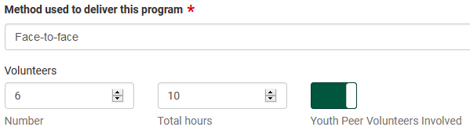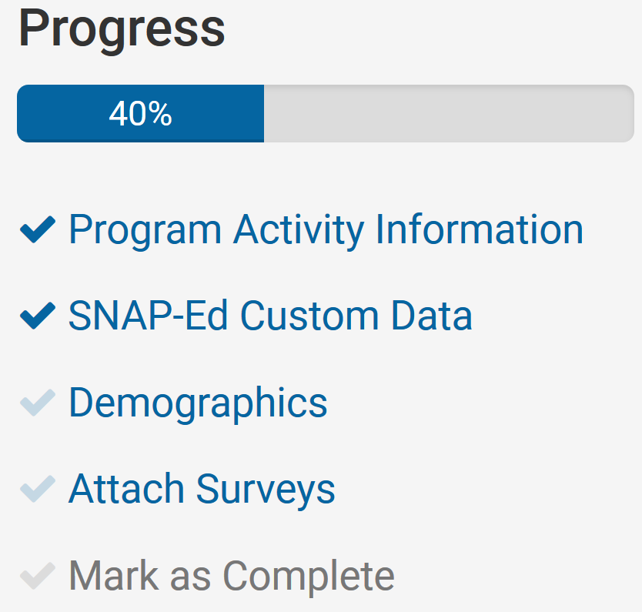

Reporting Youth Engagement in PEARS PSE Activities:
Demographics
- Only report the number of youth actively involved in shaping the PSE – do not report the number of youth reached by the PSE.
- Include in the comments section the youth-led PSE for that site and a brief description of the youth-led activity.
Where to indicate youth involvement in PSEs in PEARS (PEARS > Track > PSE Site Activities):
- Select Strategy from the right-side toolbar (see screenshot below)
- If youth were actively involved in shaping this PSE, select Yes from the dropdown; then indicate the number of youth actively involved in shaping the PSE (this is not the number of youth reached by the PSE).
- If implementing YPAR, please also select YPAR as a Program, Package, or Initiative in the Strategy section.
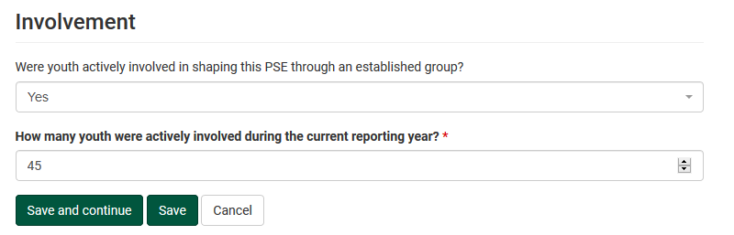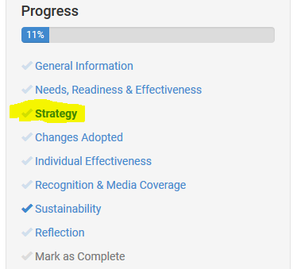
*To report interventions impacted by COVID-19 please follow the guidance outlined in the documents below:
Delivery & Reporting Guidelines: Distance learning during COVID-19
Capturing Interventions Impacted by COVID-19 in PEARS

